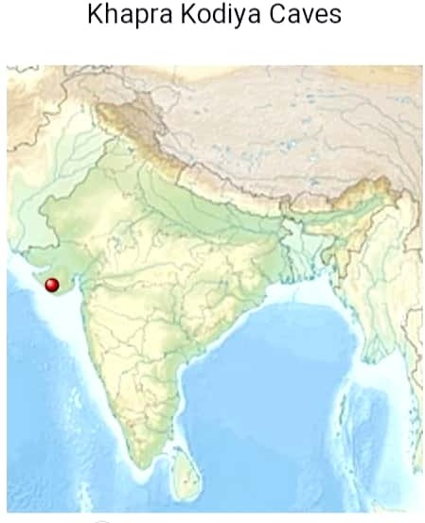

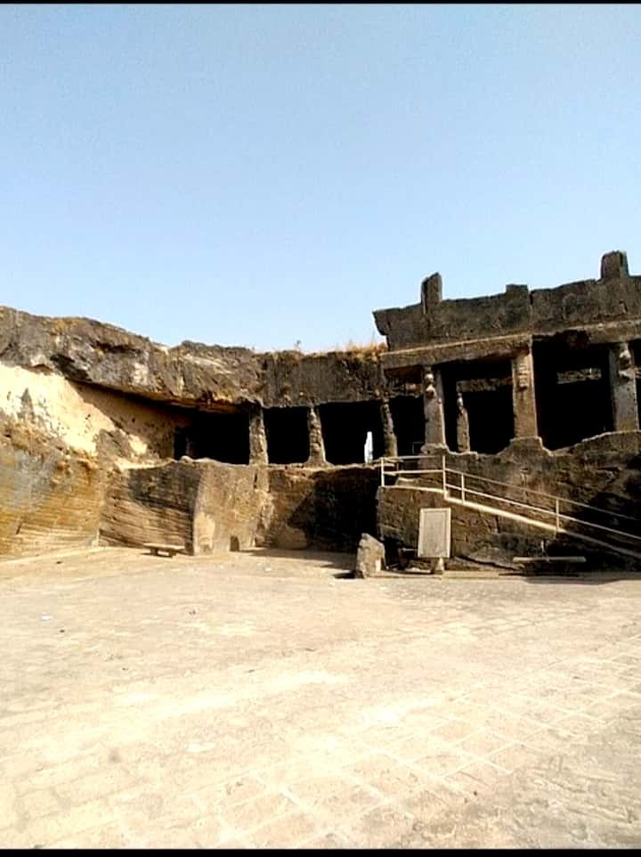

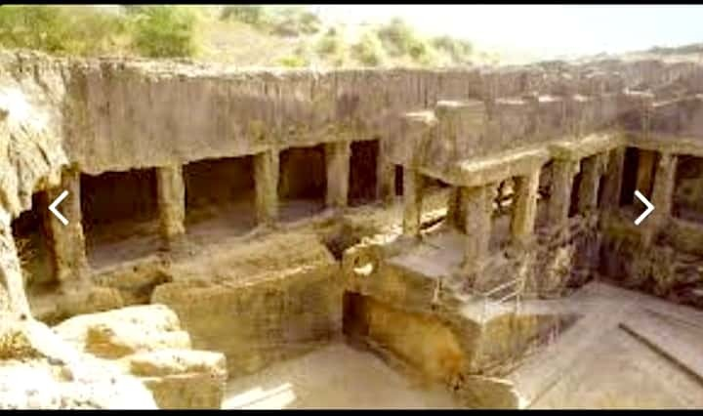

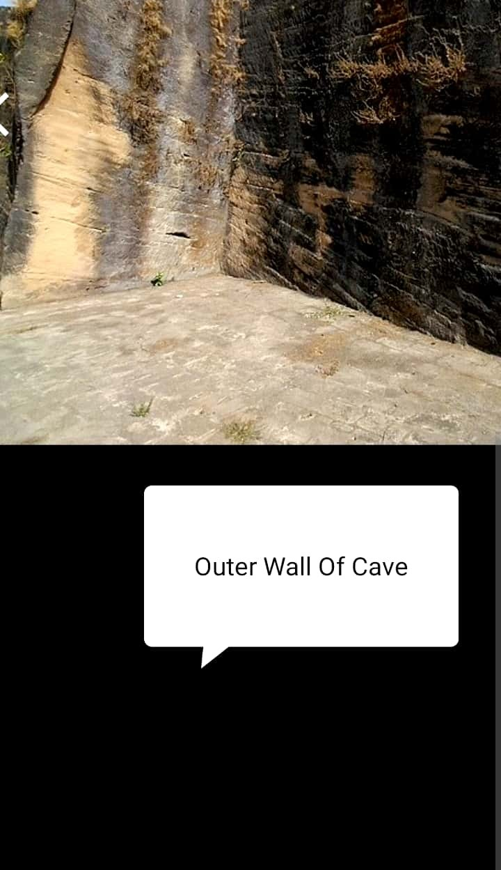

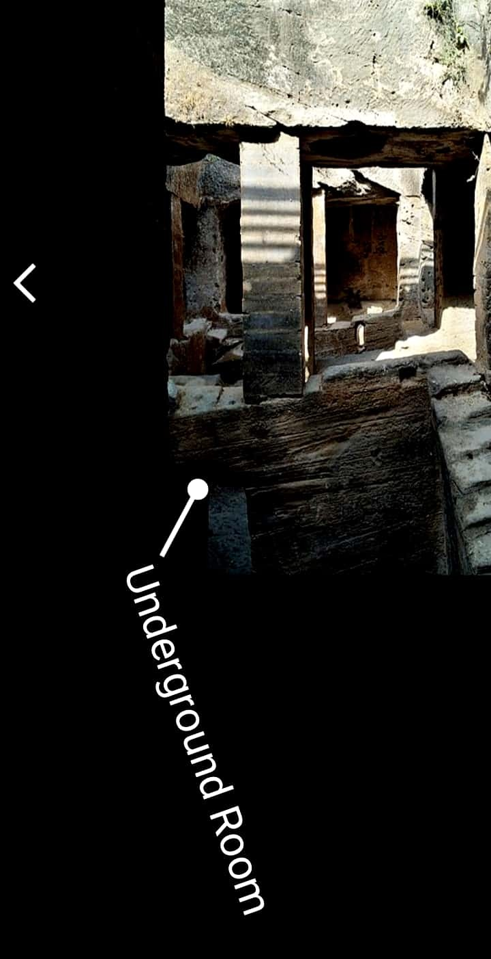

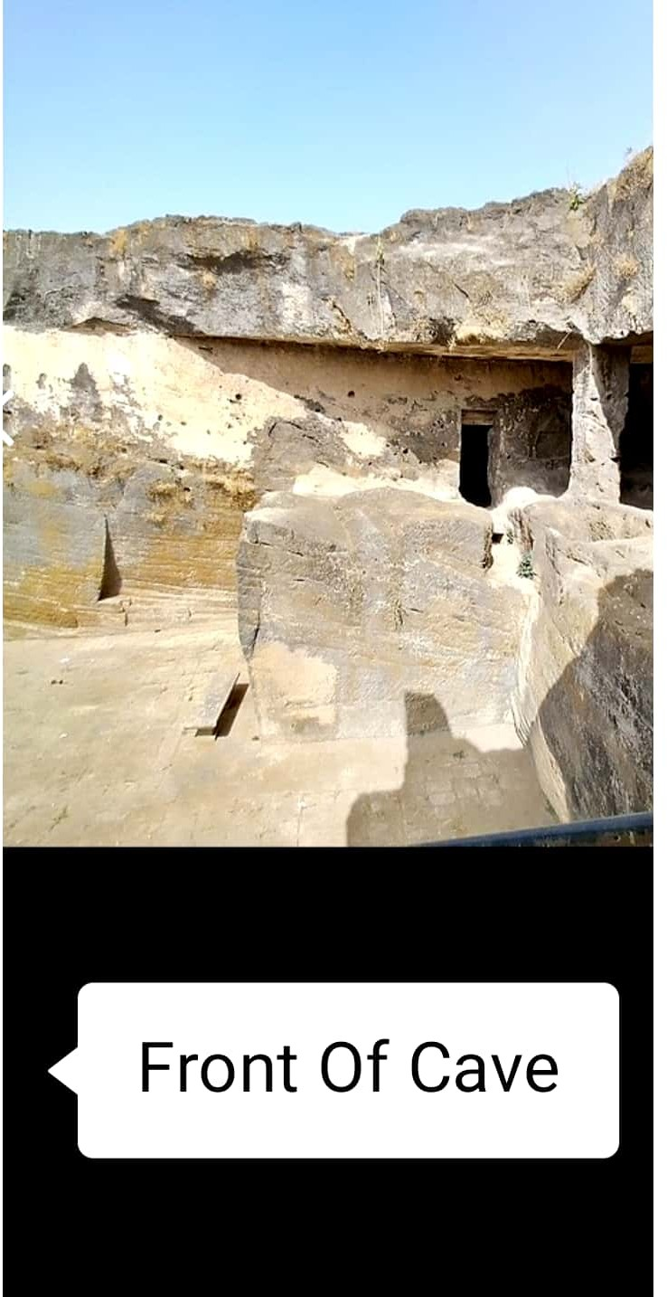

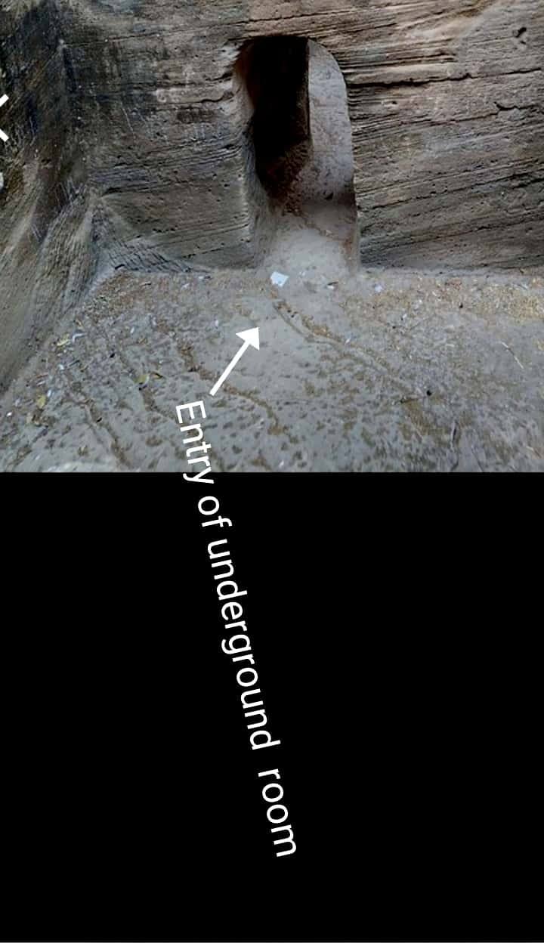

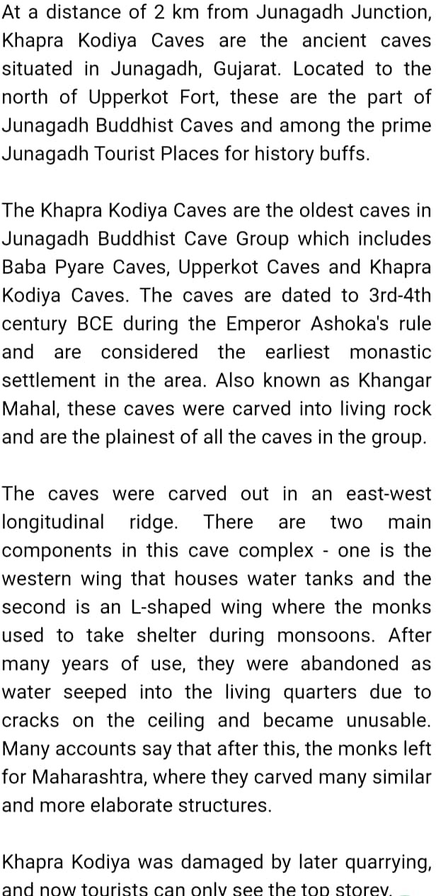

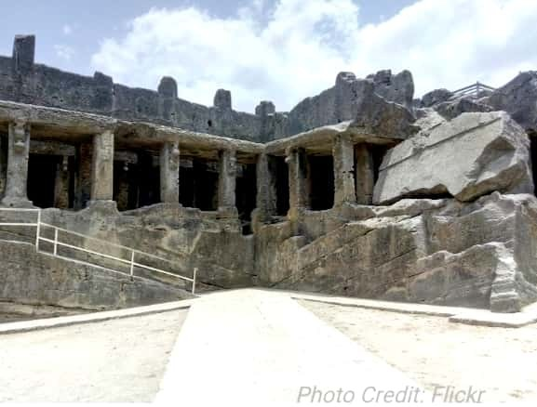






The oldest, the Khapara Kodia caves belong to 3rd-4th century AD and are the plainest of all cave groups. These caves are along the edge of the ancient Sudarshan Lake (which no longer exists) and the northern side of Uparkot. The chambers are separated into an east-west longitudinal crest. The rectangle western wing and the L’ shaped wing used by the Monks as a monsoon shelter, are important parts of the caves. They w carved into living rock during the reigr Emperor Ashoka and are considered earliest monastic settlement in the ar After many years of use, they w abandoned because cracks above th  allowed water to seep into living quart‹
rendering them unusable. Many accou say that after this, the monks left Tor Maharashtra, where they went on to carve many similar and more elaborate structures. Khapara Kodia was damaged by later quarrying, and now only the highest story remains.

